TASK 1: (CODE WORKOUT 1)
Code:
#include <stdio.h>
#include <stdlib.h>
#include <pthread.h>
#include <semaphore.h>

#define MAX_ITEMS 5
sem_t empty;
sem_t full;
int buffer[MAX_ITEMS];
int in = 0;
int out = 0;

void *producer(void *pno)
{
int item;
for(int i = 0; i < MAX_ITEMS; i++) {
item = rand(); // Produce an random item
sem_wait(&empty);
// Critical section
buffer[in] = item;
printf("Producer %d: Insert Item %d at %d\n", *((int *)pno),buffer[in],in);
in = (in+1)%MAX_ITEMS;
sem_post(&full);
}
}

void *consumer(void *cno)
{
for(int i = 0; i < MAX_ITEMS; i++) {
sem_wait(&full);
// Critical section
int item = buffer[out];
printf("Consumer %d: Remove Item %d from %d\n",*((int *)cno),item, out);
out = (out+1)%MAX_ITEMS;
sem_post(&empty);
}
}

int main()
{
pthread_t pro[5],con[5];
sem_init(&empty,0,MAX_ITEMS);
sem_init(&full,0,0);

int a[5] = {1,2,3,4,5}; //Just used for numbering the producer and consumer

for(int i = 0; i < 5; i++) {
pthread_create(&pro[i], NULL, (void *)producer, (void *)&a[i]);
}
for(int i = 0; i < 5; i++) {
pthread_create(&con[i], NULL, (void *)consumer, (void *)&a[i]);
}

for(int i = 0; i < 5; i++) {
pthread_join(pro[i], NULL);
}
for(int i = 0; i < 5; i++) {
pthread_join(con[i], NULL);
}

sem_destroy(&empty);
sem_destroy(&full);

return 0;
}
OUTPUT:

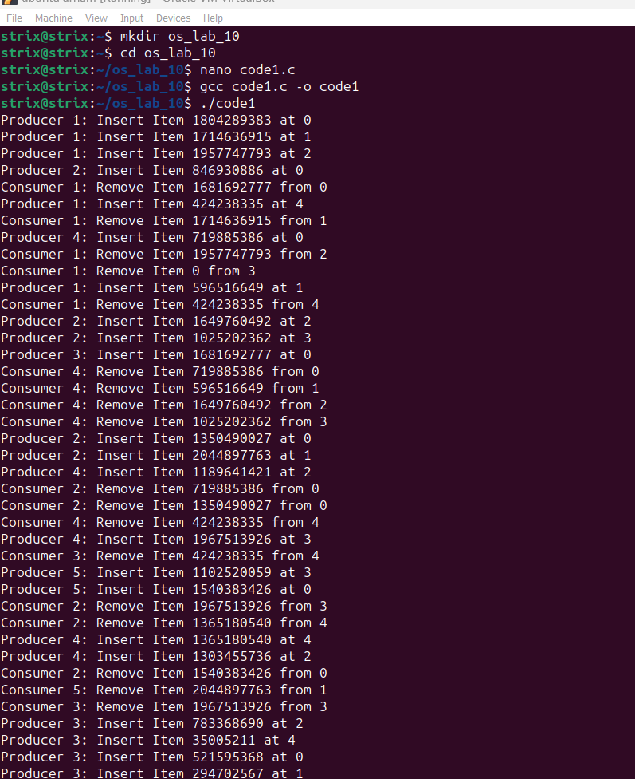
1B):
In producer-consumer problem, the full and empty semaphores play a crucial role in managing access to the buffer that both producers and consumers interact with.
- The empty semaphore represents the count of empty slots available in the buffer. It is initialized to the size of the buffer, indicating that initially, all slots are empty and available for the producer to fill. When a producer produces an item, it performs a sem_wait(&empty) operation before placing the item into the buffer. This operation decrements the empty semaphore’s value. If the buffer is full (meaning empty is zero), the sem_wait call will block the producer, preventing it from adding more items until a consumer consumes an item and increments the empty semaphore by performing a sem_post(&empty) operation.
- The full semaphore indicates the count of items currently in the buffer. It starts at zero, as the buffer is initially empty. When a producer adds an item to the buffer, it performs a sem_post(&full) operation, which increments the full semaphore’s value. Conversely, before a consumer can remove an item from the buffer, it must perform a sem_wait(&full) operation, which decrements the full semaphore’s value. If the buffer is empty (meaning full is zero), the sem_wait call will block the consumer, preventing it from removing items until a producer adds an item and increments the full semaphore.
1C):
It is typically used to simulate the time taken for production and consumption processes, respectively. It helps to mimic a more realistic scenario where these operations do not occur instantaneously.
For the producer, the sleep() function can represent the time taken to produce an item before placing it into the buffer. This could be due to various reasons such as gathering raw materials, processing, or assembly time in a real-world production environment.
For the consumer, the sleep() function can simulate the time taken to consume or process an item removed from the buffer. This could involve inspecting the item, integrating it into another system, or any other form of consumption that takes time.

TASK 2 (CODE WORKOUT 2):
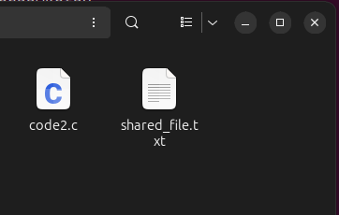
Execution:
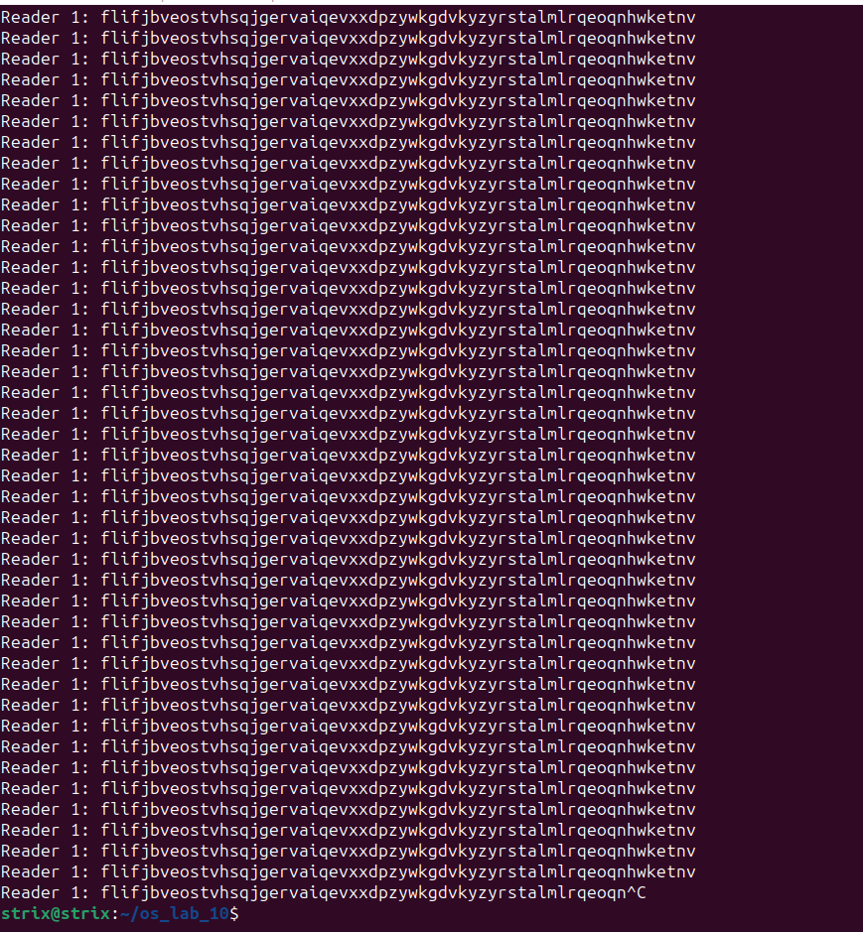
Initial text:
After execution:
